Basics of FIR Filter Design

# Summary

This document overviews the fundamentals and basic understandings need to design windowed Finite Impulse Response (FIR) filters.

# 1 Basic Ideal Filters

## Ideal All Pass Filter

The ideal all pass filter is a filter which passes all frequencies with no attenuation. The ideal normalized version of this filter would possess a unity gain across the frequency response from –π to +π.

### Inverse Discrete Time Fourier Transform Method

One way to realize filter taps for the ideal all pass filter is to apply the Inverse Discrete Time Fourier Transform to a frequency response possessing the characteristics of the all pass response.

$$x\left[k\right]= \int_{-π}^{π}{X\left(ω\right)* e^{j*ω*k}\frac{dω}{2*π}}$$

Equation 1: Inverse Discrete Time Fourier Transform

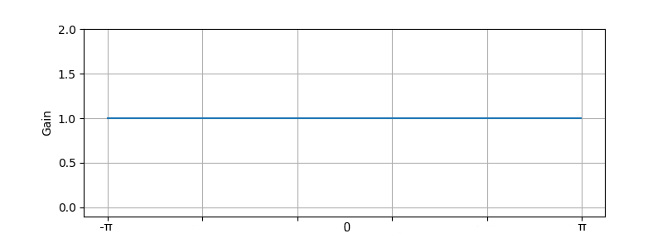

Figure 1: Ideal All Pass Filter Frequency Response

$$x\left[k\right]= \int_{-π}^{π}{1 * e^{j*ω*k}\frac{dω}{2*π}}= \int_{-π}^{π}{e^{j*ω*k}\frac{dω}{2*π}}$$

$$x\left[k\right]={\left.\frac{1}{2π}* \frac{e^{j*ω*k}}{j*k} \right|}_{-π}^{π}$$

$$x\left[k\right]=\frac{e^{jπk}-e^{-jπk}}{2πjk}= \frac{\sin{(πk)}}{πk}$$

$$x\left[k\right]=\frac{\sin{(πk)}}{πk}$$

When $k≠0 x[k]=0$:

$k=-2; x\left[-2\right] = \frac{sin⁡(-2π)}{-2π} =0$ $k=-1; x\left[-1\right]=\frac{sin⁡(-π)}{-π} =0$

$k=1; x\left[1\right]=\frac{sin⁡(π)}{π} =0$ $k=2; x\left[2\right]=\frac{sin⁡(2π)}{2π} =0$

This is because $sin⁡(πk)$ for all k is equal to 0.

When $k=0$ the limit as k approaches 0 using L'Hôpital's rule can be taken to evaluate $x[0]$:

$$x\left[0\right]= \lim_{k→0}{\frac{sin⁡(πk)}{πk}=\frac{\sin{(π*0)}}{π*0}=\frac{0}{0}}$$

This first attempt at taking the limit as k approaches 0 results in an indeterminate form, L'Hôpital's rule would have us take derivative of the numerator and denominator and again attempt to find the limit as k approaches 0.

$$x\left[0\right]= \lim_{k→0}{\frac{\frac{d}{dk}sin⁡(πk)}{\frac{d}{dk}πk}}=\lim_{k→0}{\frac{π*cos{(π*k)}}{π}}=\frac{π*cos{(π*0)}}{π}=\frac{π*1}{π}=\frac{π}{π}=1$$

$$x\left[0\right]=1$$

When $k=0$ $x\left[0\right]=1$ and when $≠0$ $x\left[k\right]=0$, this set of taps resemble a dirac delta or impulse function $δ[k]$.

The ideal All Pass Filter would possess an infinite set of taps, $x[k]$, which would resemble $δ[k]$.

$$x\left[k\right]= \frac{\sin{(πk)}}{πk}= δ[k]$$

$$x\left[k\right]= δ[k]$$

Equation 2: Ideal All Pass Filter Taps

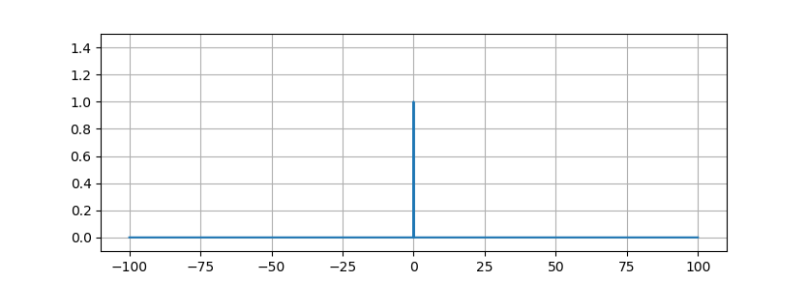

Figure 2: Truncated Ideal All Pass Filter taps from $k=-100$ to $k=+100$

## Ideal Low Pass Filter

The ideal low pass filter is a filter which passes all frequencies before a cutoff frequency, ωc*[1], and eliminates all frequencies beyond that frequency cutoff. The ideal normalized version of this filter would possess a unity gain across the frequency response from – ωc to + ωc, and would completely eliminate, multiply by 0, frequencies from –π to -ωc and frequencies after +ωc to +π.

### Inverse Discrete Time Fourier Transform Method

One way to realize filter taps for the ideal low pass filter is to apply the Inverse Discrete Time Fourier Transform to a frequency response possessing the characteristics of the ideal low pass response.

$$x\left[k\right]= \int_{-π}^{π}{X\left(ω\right)* e^{j*ω*k}\frac{dω}{2*π}}$$

Equation 3: Inverse Discrete Time Fourier Transform

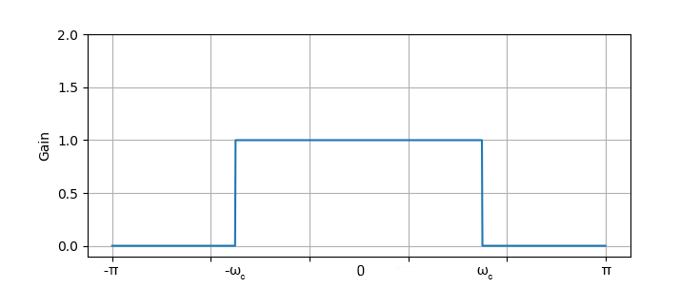

Figure 3: Ideal Low Pass Filter Frequency Response

$$x\left[k\right]= \int_{-ω_{c}}^{ω_{c}}{1 * e^{j*ω*k}\frac{dω}{2*π}}= \int_{-ω_{c}}^{ω_{c}}{e^{j*ω*k}\frac{dω}{2*π}}$$

$$x\left[k\right]={\left.\frac{1}{2π}* \frac{e^{j*ω*k}}{j*k} \right|}_{-ω_{c}}^{ω_{c}}$$

$$x\left[k\right]=\frac{e^{jω_{c}k}-e^{-jω_{c}k}}{2πjk}= \frac{\sin{(ω_{c}k)}}{πk}$$

$$x\left[k\right]= \frac{\sin{(ω_{c}k)}}{πk}$$

Using the same reasoning from the all pass taps derivation, L'Hôpital's rule can be used to find the limit as k approaches 0:

$$x\left[0\right]= \lim_{k→0}{\frac{\frac{d}{dk}sin⁡(ω_{c}k)}{\frac{d}{dk}πk}}=\lim_{k→0}{\frac{ω_{c}*cos{(ω_{c}*k)}}{π}}=\frac{ω_{c}*cos{(ω_{c}*0)}}{π}=\frac{ω_{c}*1}{π}=\frac{ω_{c}}{π}$$

$$x\left[0\right]=\frac{ω_{c}}{π}$$

The ideal Low Pass Filter would possess an infinite set of taps, $x[k]$, which would resemble the following equation:

$$x\left[k\right]=\frac{\sin{(ω_{c}k)}}{πk}$$

Equation 4: Ideal Low Pass Filter Taps

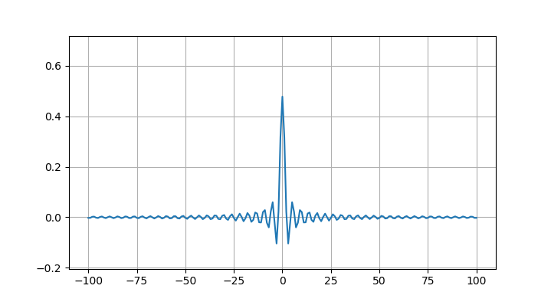

Figure 4: Truncated Ideal Low Pass Filter Taps from $k=-100$ to $k=+100$; $ω_{c}=1.5$

## Ideal High Pass Filter

The ideal high pass filter would be opposite of the ideal low pass filter. It would be a filter which blocks all frequencies before a cutoff frequency, ωc, and passes all frequencies beyond that frequency cutoff. The ideal normalized version of this filter would possess a unity gain across the frequencies from –π to -ωc and frequencies after +ωc to +π, and would completely eliminate, multiply by 0, frequencies from – ωc to + ωc.

Two methods are used here for deriving tap values which, theoretically, could be used to recreate the ideal high pass filter frequency response. The first method is the same inverse discrete time Fourier transform method used for the low pass and all pass tap derivations. The second is derived using a systems perspective and relating the high pass response to a system of all pass and low pass system blocks.

### Inverse Discrete Time Fourier Transform Method

One way to realize filter taps for the ideal high pass filter is to apply the Inverse Discrete Time Fourier Transform to a frequency response possessing the characteristics of the ideal high pass response.

$$x\left[k\right]= \int_{-π}^{π}{X\left(ω\right)* e^{j*ω*k}\frac{dω}{2*π}}$$

Equation 5: Inverse Discrete Time Fourier Transform

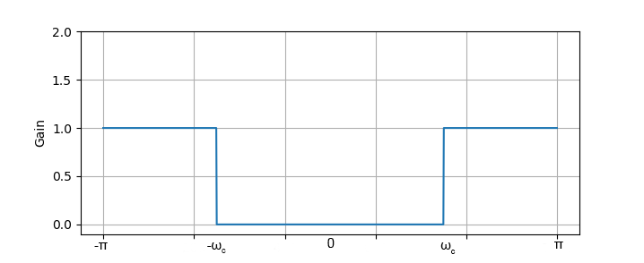

Figure 5: Ideal High Pass Filter Frequency Response

$$x\left[k\right]= \int_{-π}^{{-ω}_{c}}{1 * e^{j*ω*k}\frac{dω}{2*π}}+ \int_{ω_{c}}^{π}{1 * e^{j*ω*k}\frac{dω}{2*π}}= \int_{-π}^{{-ω}_{c}}{e^{j*ω*k}\frac{dω}{2*π}}+ \int_{ω_{c}}^{π}{e^{j*ω*k}\frac{dω}{2*π}}$$

$$x\left[k\right]={\left.\frac{1}{2π}* \frac{e^{j*ω*k}}{j*k} \right|}_{-π}^{-ω_{c}}+ {\left.\frac{1}{2π}* \frac{e^{j*ω*k}}{j*k} \right|}_{ω_{c}}^{π}$$

$$x\left[k\right]=\frac{e^{-jω_{c}k}-e^{-jπk}}{2πjk}+ \frac{e^{jπk}-e^{jω_{c}k}}{2πjk}=\frac{e^{jπk}-e^{-jπk}}{2πjk}+ \frac{e^{-jω_{c}k}-e^{jω_{c}k}}{2πjk}$$

$$x\left[k\right]= \frac{e^{jπk}-e^{-jπk}}{2πjk}- \frac{e^{jω_{c}k}-e^{-jω_{c}k}}{2πjk}$$

$$x\left[k\right]= \frac{\sin{(πk)}}{πk}- \frac{\sin{(ω_{c}k)}}{πk}$$

Referring back to the derivation of the Ideal All Pass Filter, recall that $\frac{\sin{(πk)}}{πk}= δ[k]$.

$$x\left[k\right]= δ[k]- \frac{\sin{(ω_{c}k)}}{πk}$$

Using L'Hôpital's rule the limit as k approaches 0 can be found:

$$x\left[0\right]= \lim_{k→0}{δ[k]}- \lim_{k→0}{\frac{\frac{d}{dk}\sin\left(ω_{c}k\right)}{\frac{d}{dk}πk}}=δ\left[0\right]-\lim_{k→0}{\frac{ω_{c}*cos{(ω_{c}*k)}}{π}}$$

$$x\left[0\right]=1- \frac{ω_{c}*cos\left(ω_{c}*0\right)}{π}=1- \frac{ω_{c}*1}{π}=1- \frac{ω_{c}}{π}$$

$$x\left[0\right]= 1- \frac{ω_{c}}{π}$$

The ideal High Pass Filter would possess an infinite set of taps, $x[k]$, which would resemble the following equation:

$$x\left[k\right]= δ[k]- \frac{\sin{(ω_{c}k)}}{πk}$$

Equation 6: Ideal High Pass Filter Taps

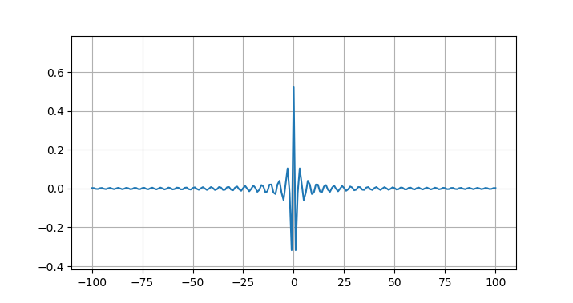

Figure 6: Truncated Ideal High Pass Filter Taps from $k=-100$ to $k=+100$; $ω_{c}=1.5$

### System Approach

Deriving filter taps for the ideal high pass filter from a systems perspective can be accomplished by realizing that the high pass response is effectively achieved by removing a low pass from an all pass response.

out

in

All Pass Filter

Low Pass Filter

+

-

Figure 7: High Pass System Derived using Low Pass and All Pass Filters

By tailoring a low pass filter to be the negative mold of the desired high pass response and then implementing the system in figure 7 a high pass output can be achieved.

Further simplifying the system into a set of taps which describes the system can be accomplished by using the taps derived from the impulse response of the system.

High Pass

Filter (x[k])

Taps

Output

$$δ[k]$$

All Pass Filter

Low Pass Filter

+

-

Figure 8: The output of the impulse Response of the system becomes taps defining a single block representation of the system

Appling the impulse response to the system goes as follows:

1. The Impulse Response of the ideal all pass produces: $δ[k]$
2. The Impulse Response of the ideal low pass produces: $\frac{sin⁡(ω_{c}k)}{πk}$
3. The application of the summing block produces the result of the system impulse response: $$x\left[k\right]= δ\left[k\right]- \frac{sin⁡(ω_{c}k)}{πk}$$
4. Simplifying the system down to a single high pass block would then be accomplished by convolving inputs to the block with the systems impulse response as opposed to applying inputs to this system.

This gives an equation for the ideal band pass taps to be:

$$x\left[k\right]= δ[k]- \frac{\sin{(ω_{c}k)}}{πk}$$

Equation 7: Ideal High Pass Filter Taps

## Ideal Band Pass Filter

The ideal band pass filter would be a filter which passes frequencies between cutoff frequencies ωa and ωb. The ideal normalized version of this filter would possess zero gain, completely eliminate signals, from frequencies –π to –ωb, -ωa to +ωa, and frequencies from +ωb to +π. This filter would possess unity gain between frequencies –ωb to -ωa and +ωa to +ωb

Two methods are used here for deriving tap values which, theoretically, could be used to recreate the ideal band pass filter frequency response. The first method is the same inverse discrete time Fourier transform method. The second is derived using a systems perspective and relating the band pass response to a system of all pass and low pass system blocks.

### Inverse Discrete Time Fourier Transform Method

One way to realize filter taps for the ideal band pass filter is to apply the Inverse Discrete Time Fourier Transform to a frequency response possessing the characteristics of the ideal band pass response.

$$x\left[k\right]= \int_{-π}^{π}{X\left(ω\right)* e^{j*ω*k}\frac{dω}{2*π}}$$

Equation 8: Inverse Discrete Time Fourier Transform

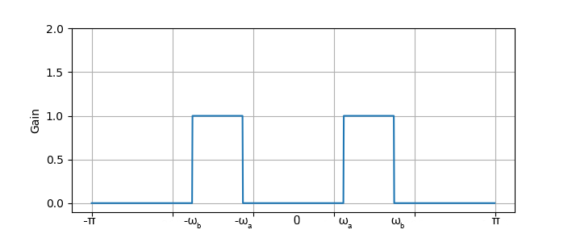

Figure 9: Ideal Band Pass Frequency Response

$$x\left[k\right]= \int_{{-ω}_{b}}^{{-ω}_{a}}{1 * e^{j*ω*k}\frac{dω}{2*π}}+ \int_{ω_{a}}^{ω_{b}}{1 * e^{j*ω*k}\frac{dω}{2*π}}= \int_{-ω_{b}}^{{-ω}_{a}}{e^{j*ω*k}\frac{dω}{2*π}}+ \int_{ω_{a}}^{ω_{b}}{e^{j*ω*k}\frac{dω}{2*π}}$$

$$x\left[k\right]={\left.\frac{1}{2π}* \frac{e^{j*ω*k}}{j*k} \right|}_{-ω_{b}}^{-ω_{a}}+ {\left.\frac{1}{2π}* \frac{e^{j*ω*k}}{j*k} \right|}_{ω_{a}}^{ω_{b}}$$

$$x\left[k\right]=\frac{e^{-jω_{a}k}-e^{-jω_{b}k}}{2πjk}+ \frac{e^{jω_{b}k}-e^{jω_{a}k}}{2πjk}=\frac{e^{jω_{b}k}-e^{-jω_{b}k}}{2πjk}+ \frac{e^{-jω_{a}k}-e^{jω_{a}k}}{2πjk}$$

$$x\left[k\right]= \frac{e^{jω_{b}k}-e^{-jω_{b}k}}{2πjk}- \frac{e^{jω_{a}k}-e^{-jω_{a}k}}{2πjk}$$

$$x\left[k\right]= \frac{\sin{(ω_{b}k)}}{πk}- \frac{\sin{(ω_{a}k)}}{πk}$$

Using L'Hôpital's rule the limit as k approaches 0 can be found:

$$x\left[0\right]= \lim_{k→0}{\frac{\sin{(ω_{b}k)}}{πk}}- \lim_{k→0}{\frac{\sin\left(ω_{a}k\right)}{πk}}=\frac{\sin\left(ω_{b}*0\right)}{π*0}-\frac{\sin\left(ω_{a}*0\right)}{π*0}=\frac{0}{0}$$

Taking the derivative of the numerators and denominators to deal with the indeterminate result:

$$x\left[0\right]= \lim_{k→0}{\frac{\frac{d}{dk}sin{(ω_{b}k)}}{\frac{d}{dk}πk}}- \lim_{k→0}{\frac{\frac{d}{dk}\sin\left(ω_{a}k\right)}{\frac{d}{dk}πk}}=\lim_{k→0}{\frac{ω_{b}*cos{(ω_{b}*k)}}{π}}-\lim_{k→0}{\frac{ω_{a}*cos{(ω_{a}*k)}}{π}}$$

$$x\left[0\right]=\frac{ω_{b}*cos{(ω_{b}*0)}}{π}- \frac{ω_{a}*cos\left(ω_{a}*0\right)}{π}=\frac{ω_{b}*1}{π}- \frac{ω_{a}*1}{π}=\frac{ω_{b}}{π}- \frac{ω_{a}}{π}$$

$$x\left[0\right]= \frac{ω_{b}}{π}- \frac{ω_{a}}{π}$$

The ideal Band Pass Filter would possess an infinite set of taps, $x[k]$, which would resemble the following equation:

$$x\left[k\right]= \frac{\sin\left(ω_{b}k\right)-\sin{(ω_{a}k)}}{πk}$$

Equation 9: Ideal Band Pass Filter Taps

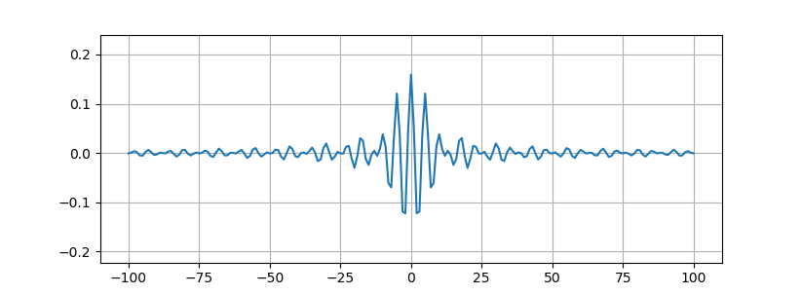

Figure 10: Truncated Ideal Band Pass Filter Taps from $k=-100$ to $k=+100$; $ω_{a}=1 ω_{b}=1.5$

### System Approach

Deriving filter taps for the ideal band pass filter from a systems perspective can be accomplished by realizing that the band pass response can be arrived at through the use of two low pass filters. A wider low pass filter, with cutoff frequency ωb, is used to secure the desired pass band, as well as deal with higher frequency content. A narrower low pass filter, with cutoff frequency ωa, is subtracted from the wider low pass filter to remove lower frequency content from the overall response.

Low Pass Filter ωb cutoff

Low Pass Filter ωa cutoff

+

-

Figure 11: System Block Diagram which would produce an Ideal Band Pass Response

The end result of such an ideal system would produce a pass band consisting of frequencies before ωb to ωa, all other frequency content would be eliminated, multiplied by zero.

Further simplifying the system into a set of taps which describes the system can be accomplished by using the taps derived from the impulse response of the system.

Band Pass

Filter (x[k])

Taps

Output

$$δ[k]$$

Low Pass Filter ωb cutoff

Low Pass Filter ωa cutoff

+

-

Figure 12: The output of the impulse Response of the system becomes taps defining a single block representation of the system

Appling the impulse response to the system goes as follows:

1. The Impulse Response of the ideal low pass with cutoff ωb produces: $\frac{sin⁡(ω_{b}k)}{πk}$
2. The Impulse Response of the ideal low pass with cutoff ωa produces: $\frac{sin⁡(ω_{a}k)}{πk}$
3. The application of the summing block produces the result of the system impulse response: $$x\left[k\right]=\frac{sin⁡(ω_{b}k)}{πk}- \frac{sin⁡(ω_{a}k)}{πk}$$
4. Simplifying the system down to a single band pass block would then be accomplished by convolving inputs to the block with the systems impulse response as opposed to applying inputs to this system.

This gives an equation for the ideal band pass taps to be:

$$x\left[k\right]= \frac{\sin\left(ω_{b}k\right)-sin⁡(ω_{a}k)}{πk}$$

Equation 10: Ideal Band Pass Filter Taps

## Ideal Band Stop Filter

The ideal band stop filter would be a filter which eliminates frequencies between cutoff frequencies ωa and ωb. The ideal normalized version of this filter would possess unity gain from frequencies –π to –ωb, -ωa to +ωa, and frequencies from +ωb to +π. This filter would possess zero gain, completely eliminate frequency content, between frequencies –ωb to -ωa and +ωa to +ωb

Two methods are used here for deriving tap values which, theoretically, could be used to recreate the ideal band stop filter frequency response. The first method is the same inverse discrete time Fourier transform method. The second is derived using a systems perspective and relating the band stop response to a system of all pass and low pass system blocks.

### Inverse Discrete Time Fourier Transform Method

One way to realize filter taps for the ideal band stop filter is to apply the Inverse Discrete Time Fourier Transform to a frequency response possessing the characteristics of the ideal band stop response.

$$x\left[k\right]= \int_{-π}^{π}{X\left(ω\right)* e^{j*ω*k}\frac{dω}{2*π}}$$

Equation 11: Inverse Discrete Time Fourier Transform

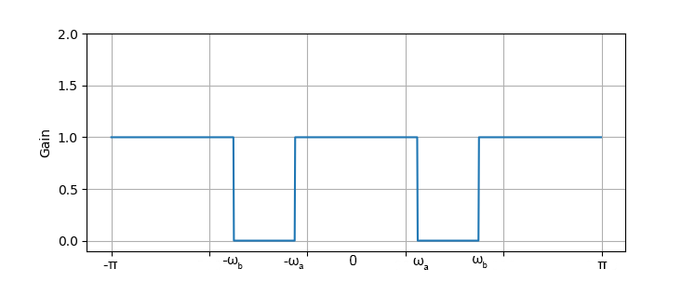

Figure 13: Ideal Band Pass Frequency Response

$$x\left[k\right]= \int_{-π}^{{-ω}_{b}}{1 * e^{j*ω*k}\frac{dω}{2*π}}+\int_{{-ω}_{a}}^{ω_{a}}{1 * e^{j*ω*k}\frac{dω}{2*π}}+ \int_{ω_{b}}^{π}{1 * e^{j*ω*k}\frac{dω}{2*π}}= \int_{-π}^{{-ω}_{b}}{e^{j*ω*k}\frac{dω}{2*π}}+\int_{{-ω}_{a}}^{ω_{a}}{e^{j*ω*k}\frac{dω}{2*π}}+ \int_{ω_{b}}^{π}{e^{j*ω*k}\frac{dω}{2*π}}$$

$$x\left[k\right]={\left.\frac{1}{2π}* \frac{e^{j*ω*k}}{j*k} \right|}_{-π}^{-ω_{b}}+{\left.\frac{1}{2π}* \frac{e^{j*ω*k}}{j*k} \right|}_{-ω_{a}}^{ω_{a}}+ {\left.\frac{1}{2π}* \frac{e^{j*ω*k}}{j*k} \right|}_{ω_{b}}^{π}$$

$$x\left[k\right]=\frac{e^{-jω_{b}k}-e^{-jπk}}{2πjk}+\frac{e^{jω_{a}k}-e^{-jω_{a}k}}{2πjk}+ \frac{e^{jπk}-e^{jω_{b}k}}{2πjk}=\frac{{-e}^{jω_{b}k}+e^{-jω_{b}k}}{2πjk}+ \frac{e^{jω_{a}k}-e^{-jω_{a}k}}{2πjk}+\frac{e^{jπk}-e^{-jπk}}{2πjk}$$

$$x\left[k\right]= \frac{e^{jπk}-e^{-jπk}}{2πjk}-\frac{e^{jω_{b}k}-e^{-jω_{b}k}}{2πjk}+ \frac{e^{jω_{a}k}-e^{-jω_{a}k}}{2πjk}$$

$$x\left[k\right]=\frac{\sin\left(πk\right)}{πk}-\frac{\sin\left(ω_{b}k\right)}{πk}+ \frac{\sin{(ω_{a}k)}}{πk}$$

Referring back to the derivation of the Ideal All Pass Filter, recall that $\frac{\sin{(πk)}}{πk}= δ[k]$.

$$x\left[k\right]=δ\left[k\right]-\frac{\sin\left(ω_{b}k\right)}{πk}+ \frac{\sin{(ω_{a}k)}}{πk}$$

Reorganizing the terms produces:

$$x\left[k\right]=δ\left[k\right]-\left(\frac{\sin{(ω_{b}k)}}{πk}- \frac{\sin{(ω_{a}k)}}{πk}\right)$$

Using L'Hôpital's rule the limit as k approaches 0 can be found:

$$x\left[0\right]=\lim_{k→0}{δ\left[k\right]}-\left(\lim_{k→0}{\frac{\sin\left(ω_{b}k\right)}{πk}}- \lim_{k→0}{\frac{\sin\left(ω_{a}k\right)}{πk}}\right) =δ\left[0\right]- \left(\frac{\sin\left(ω_{b}*0\right)}{π*0}-\frac{\sin\left(ω_{a}*0\right)}{π*0}\right)=1-\frac{0}{0}$$

Taking the derivative of the numerators and denominators to deal with the indeterminate result:

$$x\left[0\right]=\lim_{k→0}{δ\left[k\right]}- \left(\lim_{k→0}{\frac{\frac{d}{dk}sin\left(ω_{b}k\right)}{\frac{d}{dk}πk}}- \lim_{k→0}{\frac{\frac{d}{dk}\sin\left(ω_{a}k\right)}{\frac{d}{dk}πk}}\right) =\lim_{k→0}{δ\left[k\right]}- \left(\lim_{k→0}{\frac{ω_{b}*cos{(ω_{b}*k)}}{π}}-\lim_{k→0}{\frac{ω_{a}*cos{(ω_{a}*k)}}{π}}\right)$$

$$x\left[0\right]=δ\left[0\right]- \left(\frac{ω_{b}*cos\left(ω_{b}*0\right)}{π}- \frac{ω_{a}*cos\left(ω_{a}*0\right)}{π}\right)=1- \left(\frac{ω_{b}*1}{π}- \frac{ω_{a}*1}{π}\right)=1- \left(\frac{ω_{b}}{π}- \frac{ω_{a}}{π}\right)$$

$$x\left[0\right]= 1- \frac{ω_{b}}{π}+ \frac{ω_{a}}{π}$$

The ideal Band Stop Filter would possess an infinite set of taps, $x[k]$, which would resemble the following equation:

$$x\left[k\right]=δ\left[k\right]-\frac{\sin\left(ω_{b}k\right)-\sin{(ω_{a}k)}}{πk}$$

Equation 12: Ideal Band Pass Filter Taps

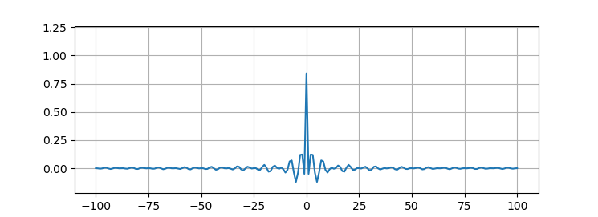

Figure 14: Truncated Ideal Band Stop Filter Taps from $k=-100$ to $k=+100$; $ω_{a}=1 ω_{b}=1.5$

### System Approach

Deriving filter taps for the ideal band stop filter from a systems perspective can be accomplished by realizing that the band stop response can be arrived at through the use of a band pass and all pass filter system. A band pass filter possessing a negative mold to the desired frequency response can be used to subtract the desired stop band from an all pass response.

All Pass

Filter

Bandpass filter with ωa to ωb pass band

+

-

Figure : System Block Diagram which would produce an Ideal Band Stop Response

+

-

Low Pass Filter ωa cutoff

Low Pass Filter ωb cutoff

All Pass

Filter

+

-

Figure 16: Expanded System Block Diagram for a Band Stop Response

The end result of such an ideal system would produce a stop band consisting of frequencies from ωb to ωa, all other frequency content would be possess unity gain.

Further simplifying the system into a set of taps which describes the system can be accomplished by using the taps derived from the impulse response of the system.

Band Stop

Filter (x[k])

Taps

Output

$$δ[k]$$

All Pass Filter

Band Pass Filter ωa to ωb cutoff

+

-

Figure : The output of the impulse Response of the system becomes taps defining a single block representation of the system

Appling the impulse response to the system goes as follows:

1. The Impulse Response of the ideal All Pass filter produces: $δ\left[k\right]$
2. The Impulse Response of the ideal Band Pass with cutoff ωa to ωb produces: $\frac{\sin\left(ω_{b}k\right)-sin⁡(ω_{a}k)}{πk}$
3. The application of the summing block produces the result of the system impulse response: $$x\left[k\right]=δ\left[k\right]-\left(\frac{\sin\left(ω_{b}k\right)-sin⁡(ω_{a}k)}{πk}\right)$$
4. Simplifying the system down to a single band stop block would then be accomplished by convolving inputs to the block with the systems impulse response as opposed to applying inputs to this system.

This gives an equation for the ideal band stop taps to be:

$$x\left[k\right]= δ\left[k\right]-\frac{\sin\left(ω_{b}k\right)-sin⁡(ω_{a}k)}{πk}$$

Equation 13: Ideal Band Stop Filter Taps

1. . $ω_{c}=2π*\frac{f_{c}}{f_{s}}$ where $f_{s}$ is the sample rate in Hertz and $f_{c}$ is the desired cutoff frequency in Hertz